Project Title:
AI System to Automatically Review and Summarize Research Papers

Internship Program: Infosys Internship
Intern Name: Pari Purswani
Mentor: Ms. M.Likhita

Project Overview

Objective
This system automates the process of creating systematic reviews of academic papers
through a structured workflow. It handles everything from initial paper search to final draft
generation using a directed graph architecture.
The current phase focuses on automated PDF text extraction, section-wise segmentation, and cross-paper analytical comparison, which form the core analytical layer required for AI-driven synthesis and structured review generation.

Task Breakdown (As Assigned by Mentor)

The following tasks were defined for the initial phase of the project:
- Implement text extraction module for parsing downloaded PDFs.
- Extract section-wise text data and store it for analysis.
- Develop key-finding extraction logic and cross-paper comparison module.
- Validate correctness and completeness of extracted textual data.
The implementation details for each task are explained below

- Implementation of Text Extraction Module
As per the Milestone 2 requirement, a dedicated text extraction module was implemented to parse downloaded research papers in PDF format and convert them into usable textual data.
A separate utility file named text_extraction_utils.py was developed to handle all PDF parsing and preprocessing tasks in a modular manner.
Module Overview – text_extraction_utils.py
This module uses PyMuPDF (fitz) for extracting machine-readable text from research papers.
The key functions implemented are:
- load_pdf() – Validates file existence and loads the PDF document
- extract_raw_text() – Extracts page-wise text using block-level parsing
- save_raw_text_to_file() – Stores extracted raw text for traceability
- clean_text() – Removes academic noise (e.g., “preprint”, “under review”) and normalizes formatting
- save_clean_text() – Saves the cleaned version of the extracted text
- split_into_sections() – Splits text into sections based on predefined academic headers
- save_sections() – Stores structured section data in JSON format
- process_pdf() – Executes the complete extraction workflow end-to-end
The module is independently executable using if __name__ == "__main__" for testing and validation.

- Handling Extraction Limitations
The system uses PyMuPDF for text extraction, which works only on machine-readable PDFs.
If a document is:
- Scanned
- Image-based
- Or contains no extractable text
The system automatically raises a controlled error indicating that the PDF is likely scanned or unsupported.
This ensures:
- Transparent failure handling
- No silent processing errors
- Clear feedback to the user
Additionally, PyMuPDF does not semantically interpret images or tables; only textual content is processed in this phase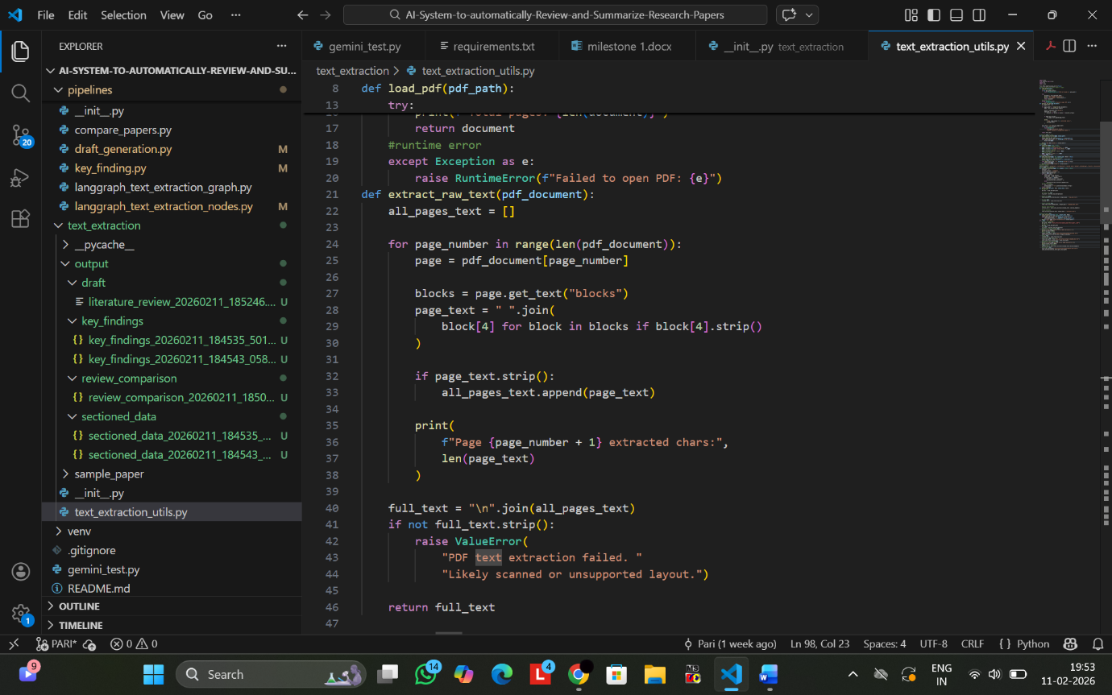
Code Snippet: Raw Text Extraction and PDF Validation
This snippet demonstrates the extract_raw_text() function, which extracts page-wise text using PyMuPDF and raises a controlled error if the PDF contains no extractable text (e.g., scanned or image-based documents), ensuring robustness in preprocessing.

- Section-wise Text Extraction and Structured Storage
As part of Milestone 2, the cleaned PDF text is semantically segmented into structured academic sections using a Large Language Model (LLM) and a LangGraph-based orchestration pipeline.
- LLM-Based Semantic Sectioning
Instead of deterministic rule-based matching, section extraction is performed using Google Gemini Flash 2.5, integrated within a LangGraph workflow.
A structured LangGraph graph is created with defined nodes responsible for:
- Receiving cleaned PDF text
- Prompting the LLM with predefined academic section ontology
- Generating structured section-wise outputs
- Passing validated outputs to storage modules
This approach enables contextual and semantic understanding of research paper structure rather than relying solely on explicit header matching.
The LLM is guided using predefined section categories such as:
- Abstracr
- introduction
- related work
- methodology
- results
- discussion
- conclusion
- references
This ensures flexible and intelligent section detection even when formatting varies across papers.
- Structured Storage and File Handling
After semantic segmentation, extracted sections are stored in structured JSON format.
Key implementation features:
- Dedicated folder for sectioned outputs
- Automatic directory creation
- UTF-8 encoding for compatibility
- Indented JSON formatting for readability
A reusable helper function, extract_json(), is implemented to safely clean and parse structured JSON responses from the LLM, ensuring reliable formatting and validation before storage.
To prevent overwriting and maintain execution traceability, timestamp-based naming is applied to output folders and files.
This enables:
- Clear separation of multiple execution runs
- Organized archival of processed research papers
- Scalable and reproducible dataset expansion

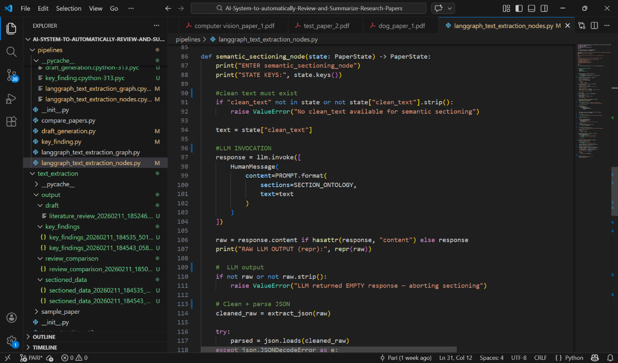
Code Snippet: LLM-Based Semantic Sectioning Node
This snippet shows the LangGraph semantic sectioning node where the cleaned paper text is processed using the Gemini 2.5 Flash LLM to extract structured academic sections in strict JSON format.
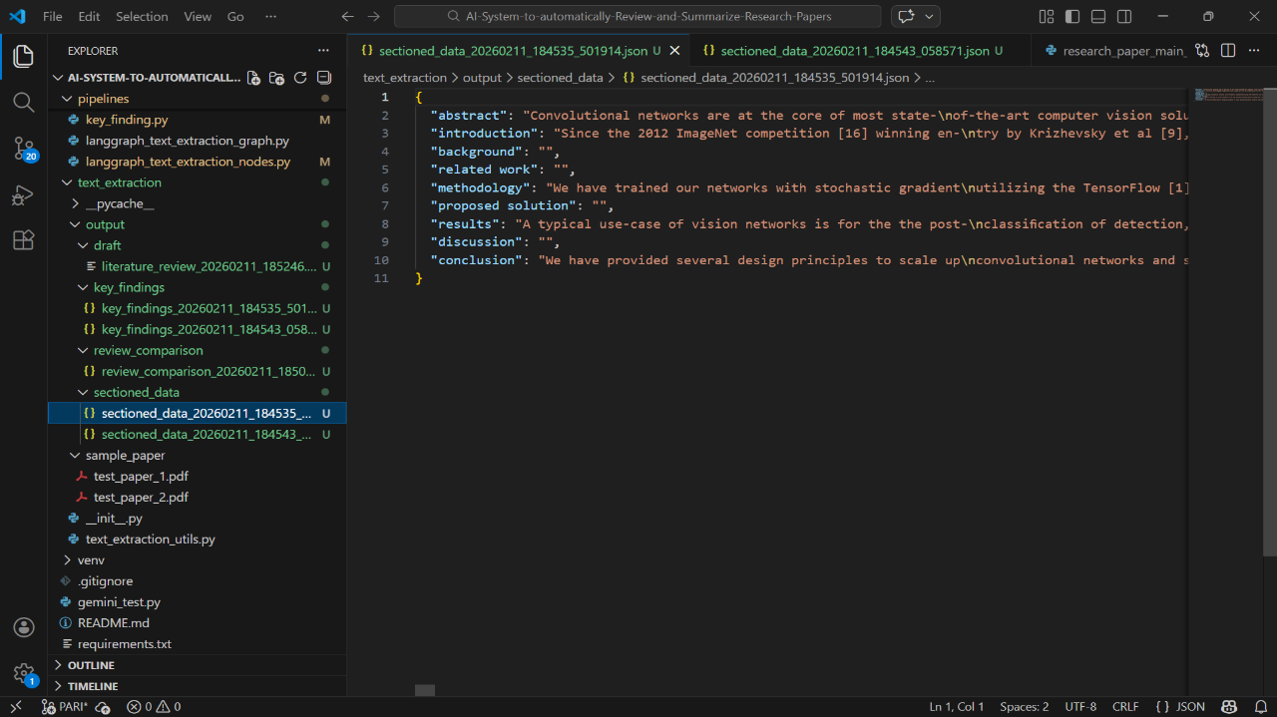
Code Snippet: Timestamped Section Storage Output
This snapshot displays the structured section-wise JSON output stored in a dedicated folder using timestamp-based file naming to prevent overwriting and ensure execution traceability.

- Key Findings Extraction and Multi-Paper Comparison
As part of Milestone 2, the system extracts structured key findings from each processed research paper and performs automated cross-paper comparison to generate literature-review style insights.
- Key Findings Extraction
Using Gemini 2.5 Flash (LLM) integrated via LangChain, the system analyzes sectioned paper content and extracts structured key findings.
Each finding includes:
- Claim
- Supporting evidence
- Source section
- Explicit limitations (if mentioned)
Strict constraints are enforced in the prompt to ensure:
- No external knowledge is added
- No inference beyond the given text
- Fully factual and text-supported outputs
A reusable JSON helper function ensures strict parsing and validation of LLM responses before storage (fail-soft error handling is implemented to prevent silent crashes).
The paper identifier remains consistent with the sectioned output ID, ensuring that extracted key findings are traceably linked to their original processed paper.
Extracted findings are stored in structured JSON format inside a dedicated output directory.
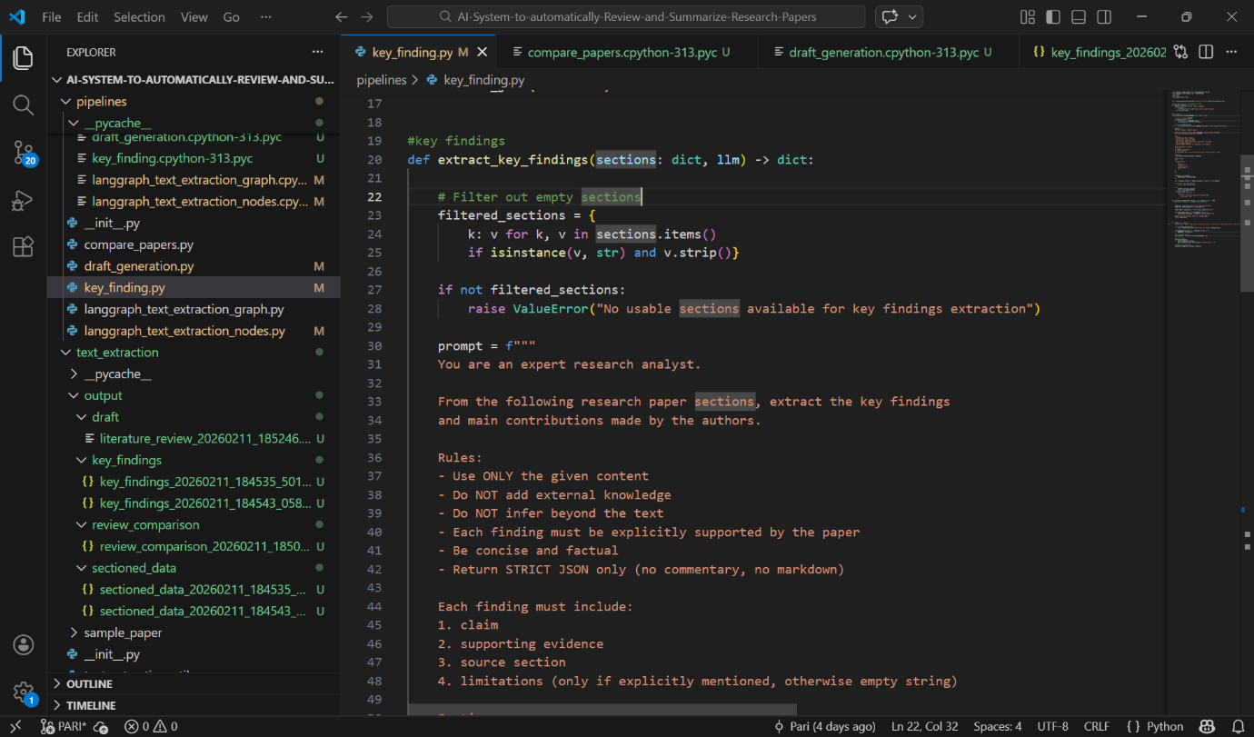
Code Snippet: Structured Key Findings Extraction
This snippet illustrates the extract_key_findings() function, where Gemini 2.5 Flash extracts claim-level insights (claim, evidence, source section, limitations) in strictly validated JSON format.

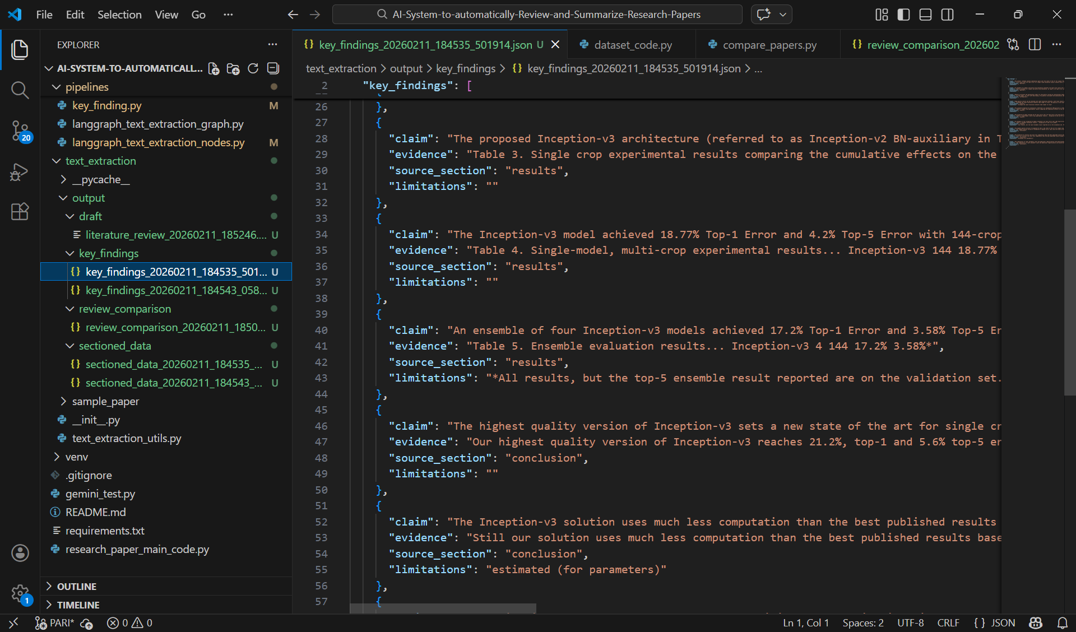
Code Snippet: Timestamped Key Findings Output
This output snapshot shows the automatically generated key findings file, uniquely stored using consistent paper identifiers to maintain linkage between section data and extracted findings.

- Automated Multi-Paper Comparison
The system automatically loads all previously generated key-finding files from the output directory and performs cross-paper comparison without manual intervention.
Key implementation features:
- Automatic aggregation of all available key findings
- Validation to ensure at least two papers are present for comparison
- LLM-based semantic clustering of related claims
- Identification of consensus, divergence, and unique contributions
The comparison output includes:
- Claim clusters (with supporting papers and evidence)
- Unique claims per paper
- Reported limitations (if available)
Timestamp-based naming is applied to comparison outputs to preserve version history and ensure organized archival of multiple review generations.
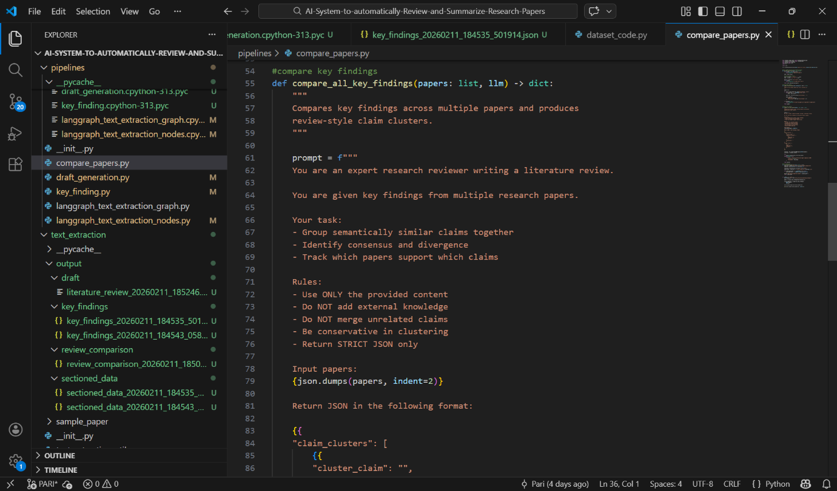
Code Snippet: Multi-Paper Comparative Analysis
This snippet demonstrates the compare_all_key_findings() function, which aggregates key findings from multiple papers and clusters semantically similar claims using structured LLM-driven comparative analysis.

- Validation of Correctness and Completeness of Extracted Textual Data
To ensure reliability and structural integrity, multiple validation mechanisms are implemented throughout the text extraction and processing pipeline.
- Structured JSON Validation
All LLM-generated outputs are processed using strict JSON helper functions (extract_json / extract_json_strict). These functions:
- Detect and isolate valid JSON objects
- Remove formatting artifacts (e.g., markdown fences)
- Raise explicit errors if no structured output is found
- Prevent malformed data from propagating downstream
This guarantees that only properly formatted and parseable structured data is accepted into the system.

- Section Completeness Checks
Before further analytical steps (key findings extraction, comparison, draft generation), the system validates:
- That extracted sections are non-empty
- That meaningful textual content exists
- That at least the required structural components are present
If no usable sections are available, the system raises a controlled exception rather than failing silently.

- Controlled Error Handling
The pipeline includes explicit safeguards for:
- Empty LLM responses
- Missing JSON objects
- Insufficient number of papers for comparison
- Missing or unreadable section files
Instead of crashing unpredictably, the system returns structured error messages, improving traceability and debugging clarity.
Additionally, during PDF processing, if no extractable text is detected (e.g., scanned or image-based PDFs), the system notifies the user that textual extraction is not possible, preventing invalid downstream processing. 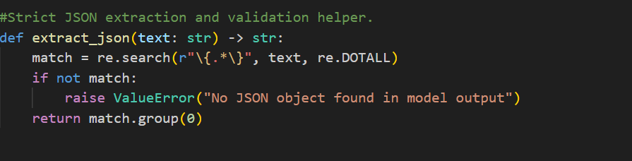
Code Snippet: Strict JSON Validation Helper
This snippet shows the extract_json_strict() validation function, which enforces structural correctness by extracting and parsing only valid JSON objects from LLM responses, preventing malformed outputs.

- Timestamp-Based Traceability
All intermediate and final outputs (sectioned data, key findings, comparisons, drafts) are stored in timestamp-based directories and filenames.
This ensures:
- No overwriting of previous runs
- Clear execution traceability
- Reproducibility of results
- Version-controlled dataset growth
Each stage of validation is therefore linked to a uniquely identifiable execution instance.

- Automated Literature Review Draft Generation
The system includes an automated draft generation module that converts structured multi-paper comparison results into a coherent academic literature review section.
- Draft Generation Using LLM
The module uses Gemini 2.5 Flash (Large Language Model) via LangChain to transform structured comparison JSON into a formal narrative review.
Key implementation features:
- Input is strictly the structured comparative analysis JSON
- The entire comparison object is formatted and injected directly into the prompt
- The model is constrained to:
  - Use only the provided content
  - Avoid external knowledge
  - Avoid hallucinated citations
  - Maintain neutral, objective academic tone
  - Introduce no new interpretations or unsupported claims
This ensures the generated draft remains fully grounded in the previously validated comparison output.

- Controlled Academic Writing Output
The prompt enforces:
- Formal academic language
- Clear paragraph structure
- Logical flow between consensus and divergent findings
- Strict adherence to structured evidence
Because the draft is generated from already clustered claims and validated JSON outputs, the narrative remains traceable to specific comparison results.

- Storage and Version Control
The generated literature review is stored as a .txt file inside a dedicated draft output directory.
Implementation details:
- Automatic directory creation
- UTF-8 encoding
- Timestamp-based file naming
- Multiple drafts can be generated without overwriting previous versions
This allows iterative refinement, reproducibility, and archival of different review generations
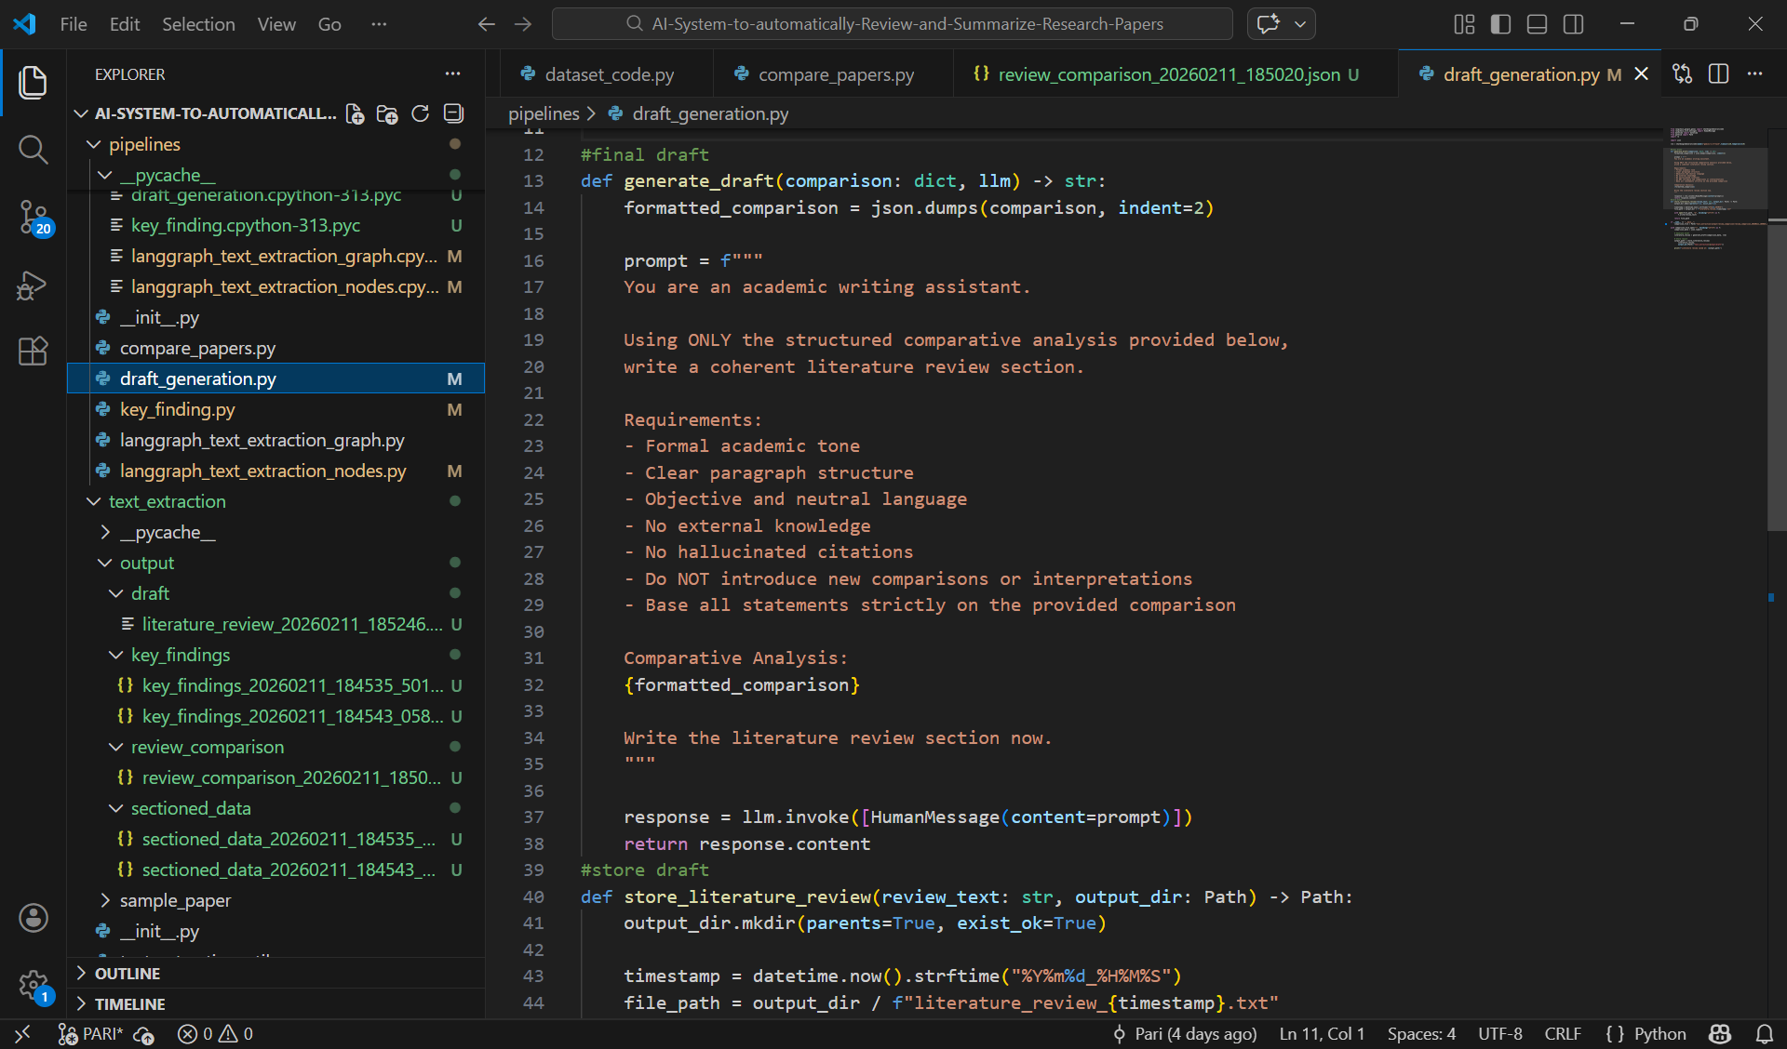
Code Snippet: Automated Literature Review Draft Generation
This snippet demonstrates the generate_draft() function, where structured comparative analysis is transformed into a coherent academic literature review using Gemini 2.5 Flash under strict instruction constraints

